Deliverable 5.3.: Final Projects
Version 1
Lead Beneficiary: | BFM
Approved by: | All Consortium
Dissemination Level: | Public

Partners
P1 | Centro Tecnológico del Mueble y la Madera de la Región de Murcia | CETEM | ES
P2 | INDRA Sistemas, S.A. | INDRA | ES
P3 | Universidad Politécnica de Cartagena | UPCT | ES
P4 | British Furniture Manufacturers | BFM | UK
P5 | Ion Technologies Ltd. | ION | UK
P6 | Open Awards Limited | OAL | UK
P7 | Centro Sperimentale del Mobile e dell’arredamento | CSM | IT
P8 | Scuola Superiore di Studi Universitari e di Perfezionamento Sant'anna | SSSA | IT
P9 | Internationaler Verein für Technische Holzfragen e.V. | IVth | GE
P10 | Karlsruher Institut Fuer Technologie | KIT | GE
P11 | European Association of Development Agencies | EURADA | BE
P12 | Regional Service for Training and Employment | SEF | ES
P13 | PILDOREA | PILDOREA | ES
P14 | INDRA SOLUCIONES TECNOLOGÍAS DE LA INFORMACIÓN S.L.U. (Minsait) | MINSAIT | ES
P15 | PRISTÁLICA SLU | PRISTÁLICA | ES

Prepared  BFM | Verifed  All Partners | Approved  All Partners

Disclaimer: The European Commission support for the production of this publication does not constitute endorsement of the contents which reflects the views only of the authors, and the Commission cannot be held responsi­ble for any use which may be made of the information contained therein.
Table of Track Changes
Version | Date | Changes
1 | 18th September2019 | First version of the document

Table of Contents

1. Introduction 4
2. Evaluation and Selection Procedure 4
3. Evaluation/Selection – 5 best FoF Solutions by platform 5
KIT - Topics, Selection Criteria and Evaluation of FoF projects
UPCT - Topics, Selection Criteria and Evaluation of FoF projects
4. BFM/Ionology - Criteria for selection of best FoF projects 8
5. Selection of the 4 best works 8
Annexes 9
References 9

Introduction

The ‘Pilot Test Experience’ as presented in Work Package 5 provides the opportunity for students, who have completed and passed all of the IN4WOOD training courses, to demonstrate the knowledge they have acquired , complimenting any previous knowledge of the Key Enabling Technologies of Industry 4.0, by presenting a ‘Factory of the Future’ solution to a chosen digital transformation scenario.

The student/worker must therefore be able demonstrate this knowledge by putting into practise, through a case study with a manufacturing/industrial scenario, in which the lack of enabling technologies of Industry 4.0 is very evident. The student/worker must work on proposing one or several technological solutions that will lead the company towards the digital transformation of Industry 4.0.

The submitted projects are to be evaluated through an output focused and criteria based review process. This process is designed to initially involve the Pilot Managers and Teachers of each of the respective training platforms i.e. KIT (Germany), CSM/ SSSA (Italy), UPCT/CETEM (Spain) and BFM (UK). Ultimately the BFM is responsible for the selection and description of the best four Factories of the Future solutions developed during the WP5 by the students/workers.

To ensure the integrity of a fair evaluation and selection process, as is reasonably practical, BFM and UK project partner Ionology (as experts in digital strategy and transformation) collaborated on the technical assessment and quality of the 4 best ‘Factories of Future’ solutions.

- Evaluation and Selection Procedure

At the 6th Consortium Meeting held in Belfast on the 15th May 2019 it was discussed and agreed that BFM is to develop and propose the procedure for project evaluation and selection. The Pilot Test Experience Managers/Teachers subsequently agreed the procedure presented by BFM as follows:-

- The Pilot Managers and Teachers for each of the respective country/language platforms (Germany, Italy, Spain, UK) are to judge, against their own developed criteria, all of the projects submitted by their students/workers and submit to BFM a maximum of 5 projects (translated into English) which they view as best meeting their country/language criteria.

- BFM will then review and compare these submissions, in collaboration with partner Ionology, using a criteria based evaluation process to determine, with justifications and conclusions, which are the 4 strongest projects that best meet the criteria ‘overall’ and rank these projects accordingly.

It was also presented and agreed that the above procedure offers a number of benefits for the Pilot Managers and students/workers alike as follows:-

- Each country/language platform is involved in promoting the best of their students FoF final works and contributes to the final selection process.

- The number of project translations required is a less onerous task.

- The risk of misunderstandings/errors though translation is reduced.

- Student incentives/prizes can be offered initially on a country/language basis as was agreed in Belfast.

- Evaluation/Selection – 5 best FOF solutions by platform

By the closing date for final project submissions KIT (Germany) received 6 FoF solutions and UPCT (Spain) received 18 FoF solutions. Italy and the UK did not receive any FoF solutions.

KIT – Topics, Selection Criteria and Evaluation of FoF projects

Kit developed their own criteria and points awarding system to evaluate and select the 5 best works from their respective project submissions.

Topics proposed for the presentation of FoF solutions were given as:-

- Integration of key enabling technologies in the Smart house/building.
- Integration of the KETs in the architectural environment and construction.
- Design of a piece of furniture integrating in design and functionality some of the new technologies explained in the IN4WOOD course.

For the delivery of the FoF works KIT proposed that the students would prepare a Power Point to present their work and ideas.

The five selected final projects developed by the KIT students were:

- Industry 4.0. iBAU TV. By Dadim Basev.
- Networked Elevator. By Julia Kapinos.
- Industry 4.0. Smart Matching. By Katharina Saharov.
- Household Separation System. By Larah Brems.
- The Cube. Tiny Living. By Lars Standop.

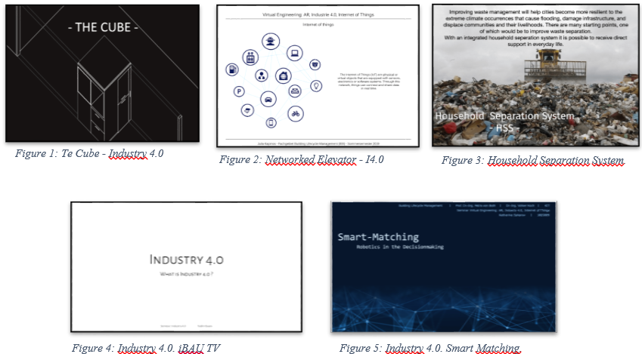

KIT Evaluation Criteria/scoring:

The score goes from 1 to 6, with 1 being the highest score and 6 being the lowest.

FoFs | Creativity | Originality | 1 or more Technologies | Presentation | Applicability | Innovative | Total Score
The Cube | 1 | 1 | 1,5 | 2 | 2,5 | 1 | 1,50
Networked Elevator | 1 | 1 | 1,3 | 1,5 | 2 | 1 | 1,30
Household Separation System | 1,6 | 1,8 | 1,2 | 2 | 1,5 | 1 | 1,52
iBAU TV | 1,5 | 1,5 | 1,1 | 2 | 2 | 1,6 | 1,62
Smart Matching | 1,5 | 1,5 | 1,2 | 2 | 1,5 | 1 | 1,45
Table 1 KIT Criteria/scoring

UPCT – Topics, Selection Criteria and Evaluation of FoF projects

UPCT developed their own criteria and points awarding system to evaluate and select the 5 best works from their respective project submissions.

Topics proposed for the presentation of FoF solutions were given as:-

- Manufacture of handmade furniture
- Factory monitoring for Big Data analysis
- Transformation from traditional industries to Industry4.0
- Traceability of furniture pallets – furniture traceability
- Any other topic which is of particular interest to the student given prior approval

For the delivery of the FoF works UPCT proposed that the students would prepare a Word document in PDF format to present their work and ideas.

The five selected final projects developed by the UPCT students were:

- Ad hoc furniture manufacturing. By Jose Cavas Alcaraz
- Artisanal furniture manufacturing. By David Cegarra Leiva
- Factory monitoring for Big Data. By Marta Martinez Minola
- Furniture traceability. By Guillermo Martinez Perez
- Ad hoc furniture manufacturing. By Miguel Tarraga Martinez

The final mark goes from 1 to 10 with 10 being the highest.

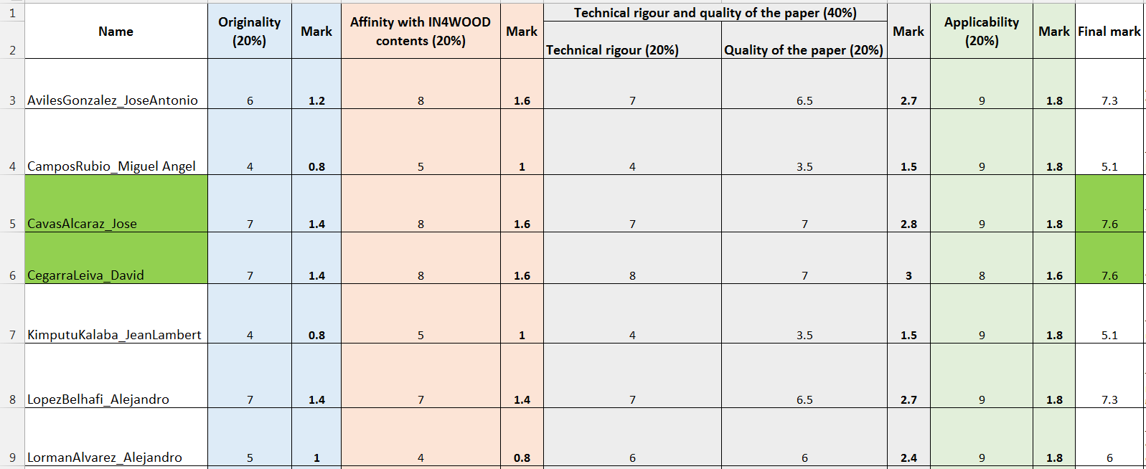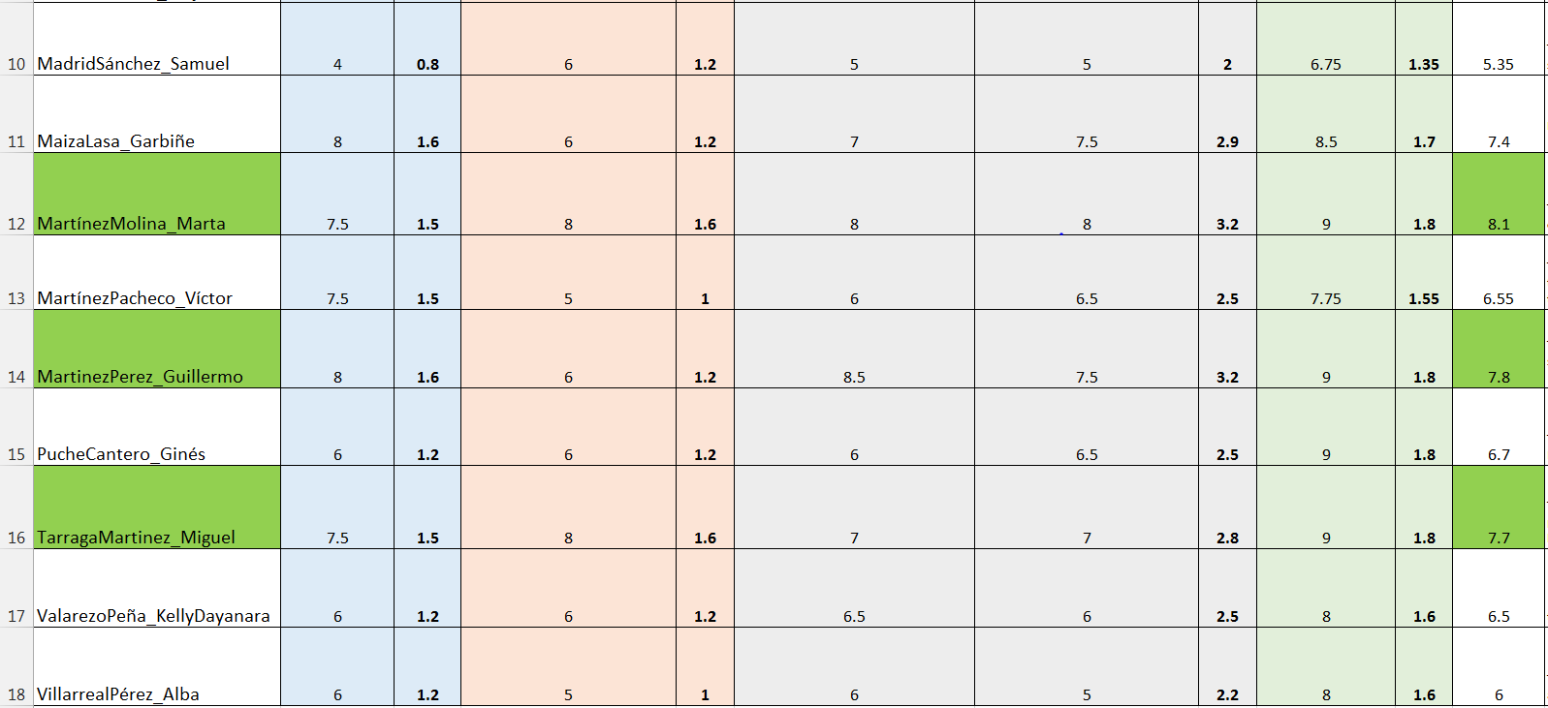

Table 2 - UPCT Criteria/scoring

BFM/Ionology – Criteria for selection of best FoF final projects

Work in progress BFM/Ionology.

Selection of the 4 best final projects
Work in progress

Annexes

References

